**JQuery Plug-in**

**navigator. notification. alert**

Shows a custom alert or dialog box. Some platforms use the browser's alert function, which is typically less customizable.

navigator.notification.alert(message, alertCallback, [title], [buttonName])

* **message**: Dialog message. *(String)*
* **alertCallback**: Callback to invoke when alert dialog is dismissed. *(Function)*
* **title**: Dialog title. *(String)* (Optional, defaults to Alert)
* **buttonName**: Button name. *(String)* (Optional, defaults to OK)

**Example- How does it work**

$('#timer-start, #timer-cancel').click(function ()

{

if (this.id == 'timer-start')

{

StartTimer ();

}

else if (this.id == 'timer-cancel')

{

StopTimer();

navigator.notification.alert('You cancelled the timer', callBackFunction, 'Timer cancelled','Ok');

}

});

function callBackFunction(){

console.log("Clicked"); }

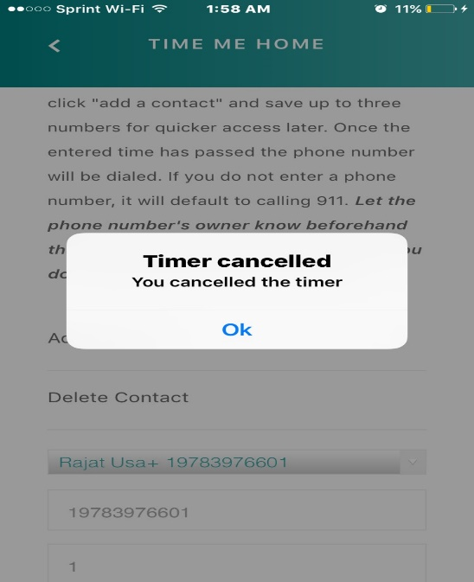

Benefits of JQuery plugin

1. Highly customizable
2. Highly Extensible
3. Easy to use (Syntax)
4. JQuery is framework of JavaScript

**window.open("tel:" + phone, '_system')**

This method window.open opens up the new window.

‘‘tel:’’ – This argument makes sure that it is a telephone number.

phone- This is variable that have phone number in it which is enter by user.

‘_system’ – Opens in system’s web browser.

**Working in IOS**

When thetimer completes the time this method automatically starts calling emergency contact or the recipient (which we added in the contacts).

**Working in Android**

When thetimer completes the time this method opens the calling option and ask you to call the emergency contact or the recipient (which we added in the contacts).